USE CASE STUDY REPORT

Group No.: Group 11
Student Names: Alice Tinna and Aryan Patidar
Executive Summary: This goal of this use case study is to create a predictive model to predict income category of over or under 50K $ based on various factors. Data has been taken from 1994 Census database provided by UCI Machine Learning Repository. So, after analyzing the data set, it is explored and cleaned by removing non-required values, which is being further used in different methods of modeling viz. Decision tree, Random forest, and Logistic analysis. Further performance is observed using confusion matrix and ROC with the help of Area under curve. Finally, according to the modelling it is been observed that Logistic Regression is the most suitable model. At last for further work, we intend to improve with different values associated with Random Forests. We would also like to try different pruning methods with Decision Trees and attempt other models as well. Finally, we would like to attempt this whole project with the full dataset which are 32560 observations instead of using 5000 observations.

I. Background and Introduction
Income of individuals play a major role in deciding any country’s future. As income is an important factor, so how great would it be if we can predict income of individuals roughly. So, in this project we are making a model to predict for an individual’s income to be over or under 50,000 $, based on various factors like age, sex, gender, occupation, education level, hours per week, race, native country etc.

- The problem –
Income depends on multiple factors and to calculate income accurately is not possible, whose value can help in any country’s planning. So, we will create a predictive model for the same, which will predict that in which domain income falls from the 2 categories.

- The goal of your study –
To predict income of an individual to be over or under 50,000 $.

- The possible solution –
Output will be from a binary category, which is over or under 50,000 $.

II. Data Exploration and Visualization
After downloading the dataset from the UCI Machine Learning Repository, read the data into R and check the structure of it.
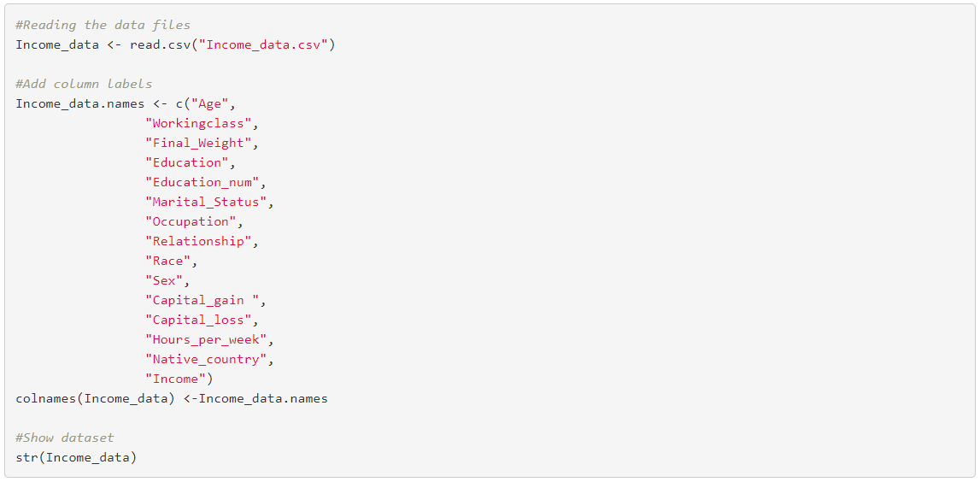
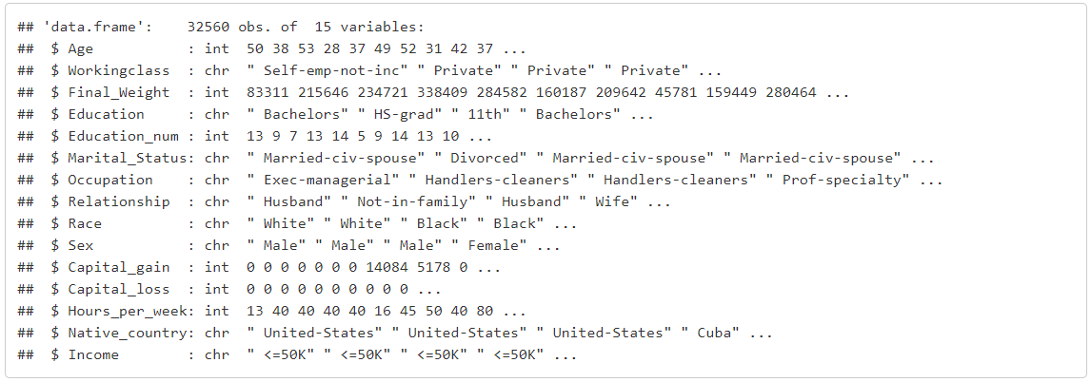
We have done this project in two parts: 1. Data Visualization 2. Data Modelling
First, we will explore the data and will do necessary visualization to understand the data better. We will try to find correlations between the variables.
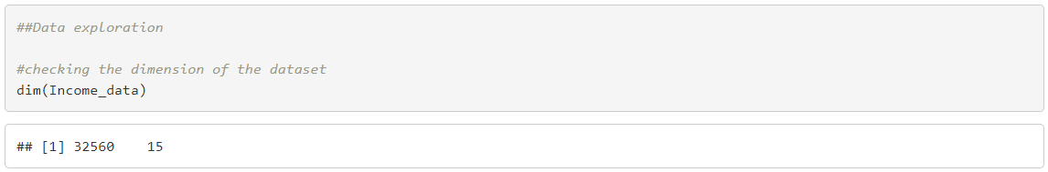
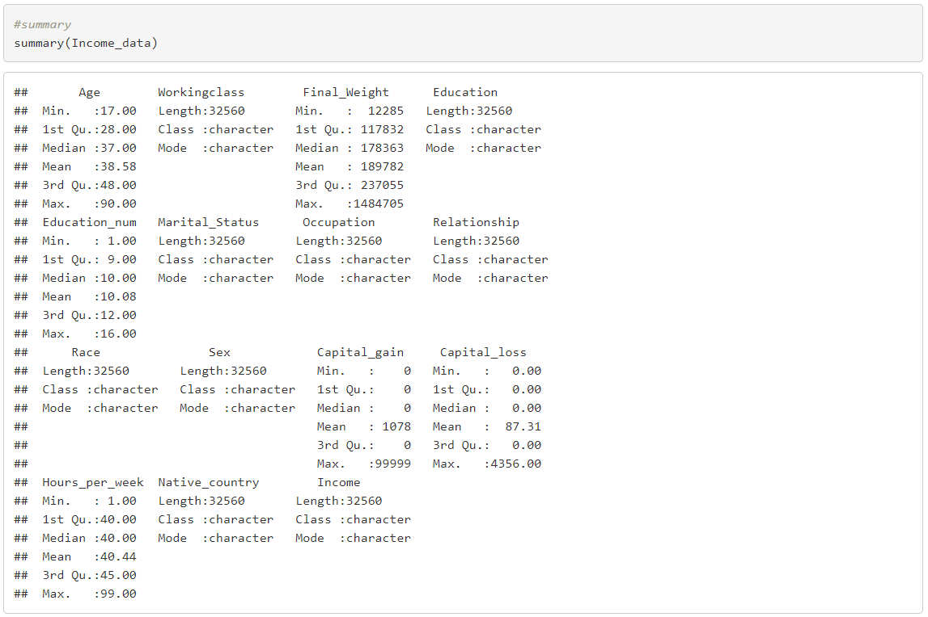

Data Visualization
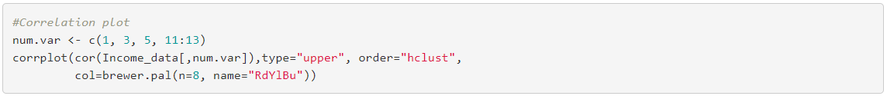
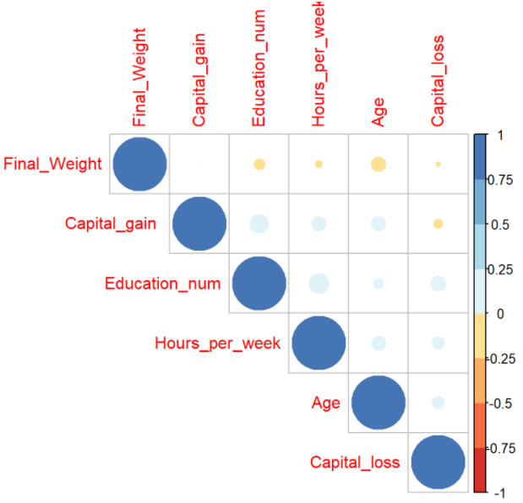
Visualizing the variables from the income data using bar graph and histogram.
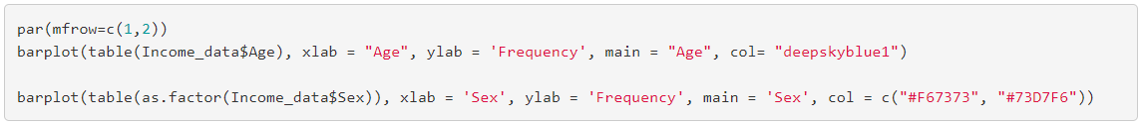
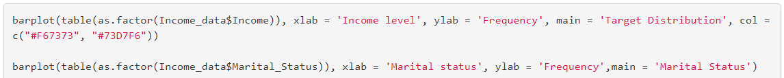
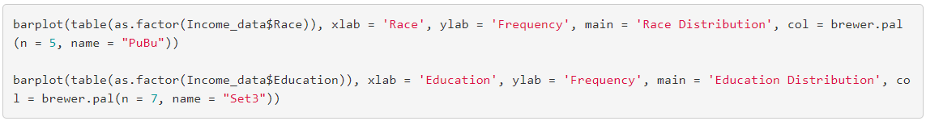
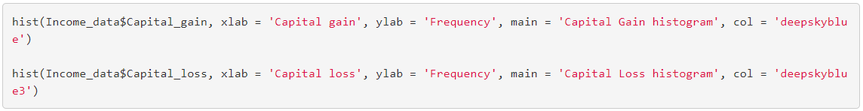
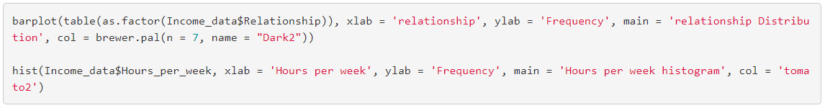
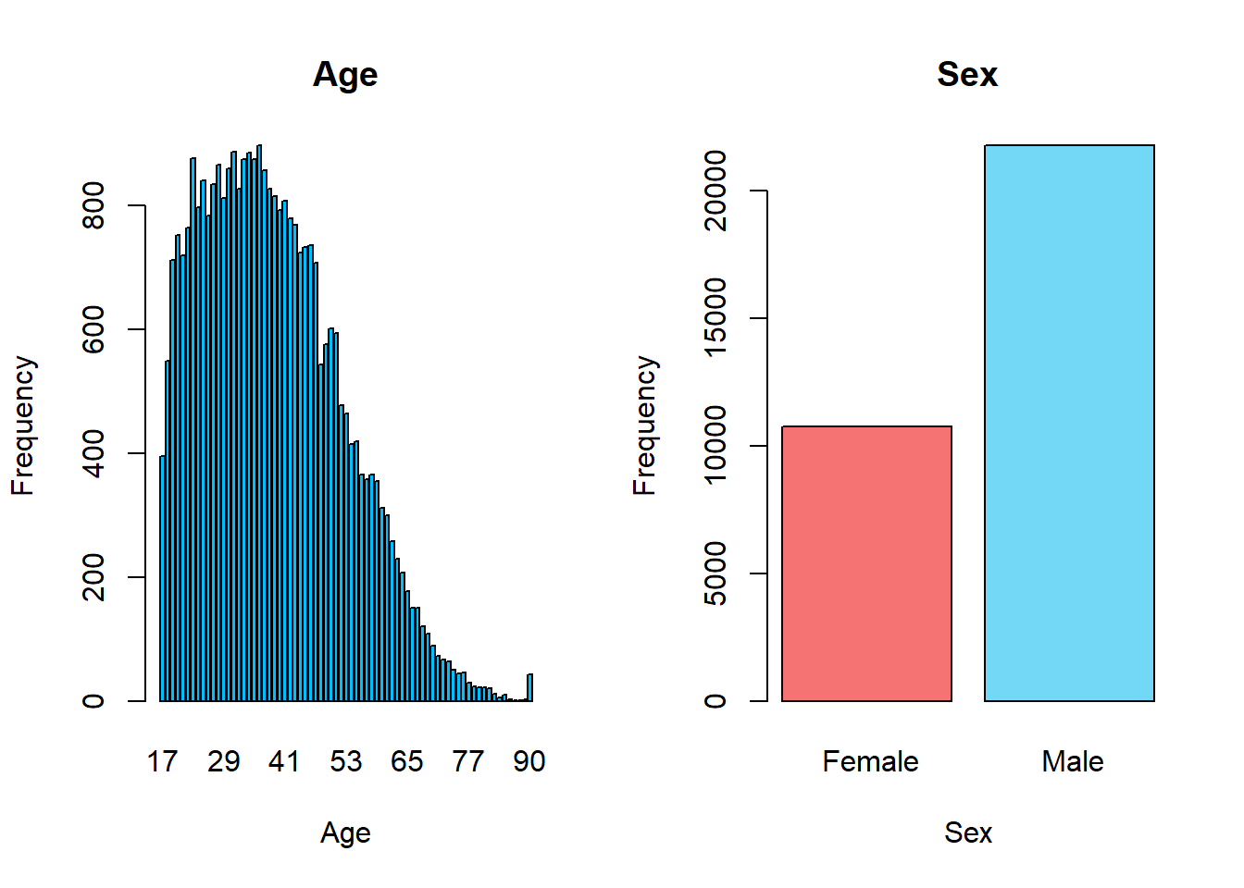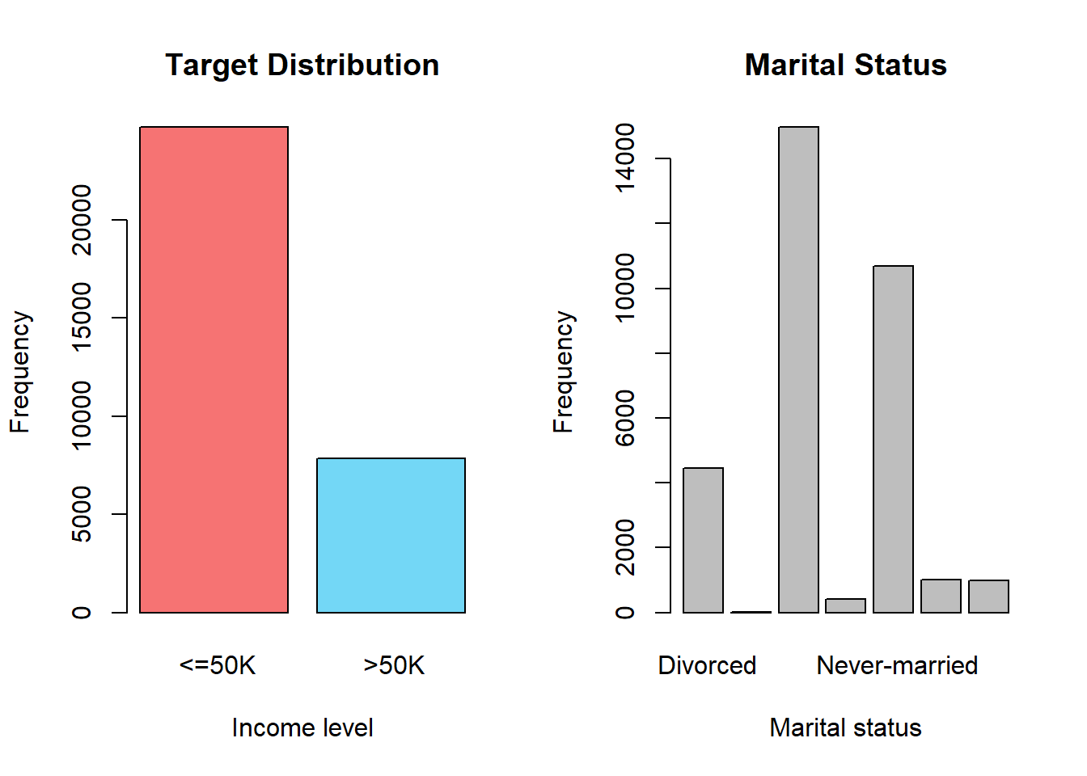
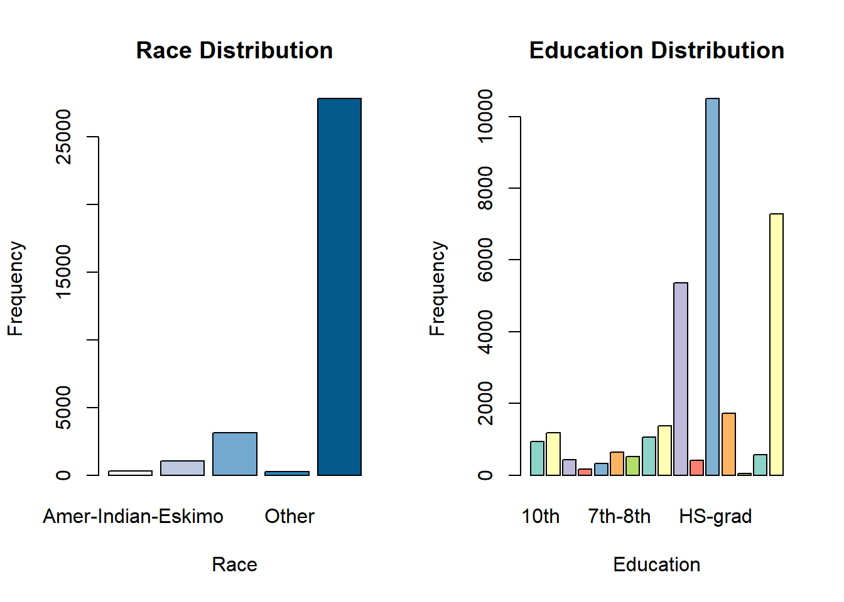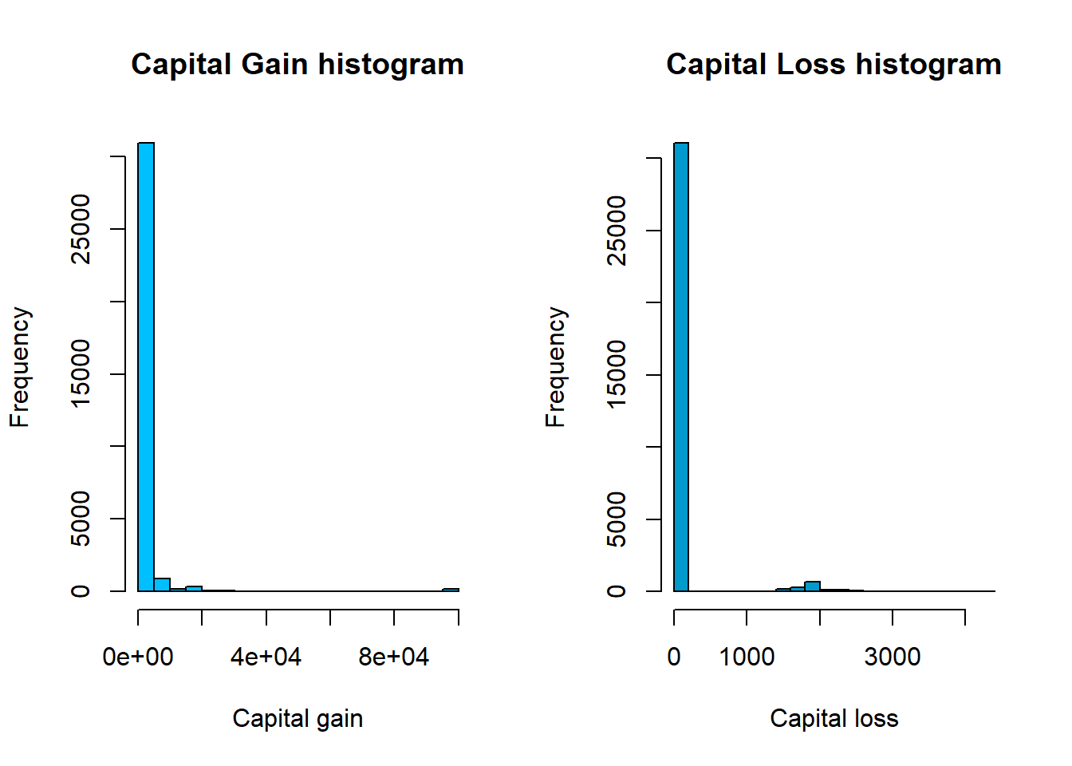
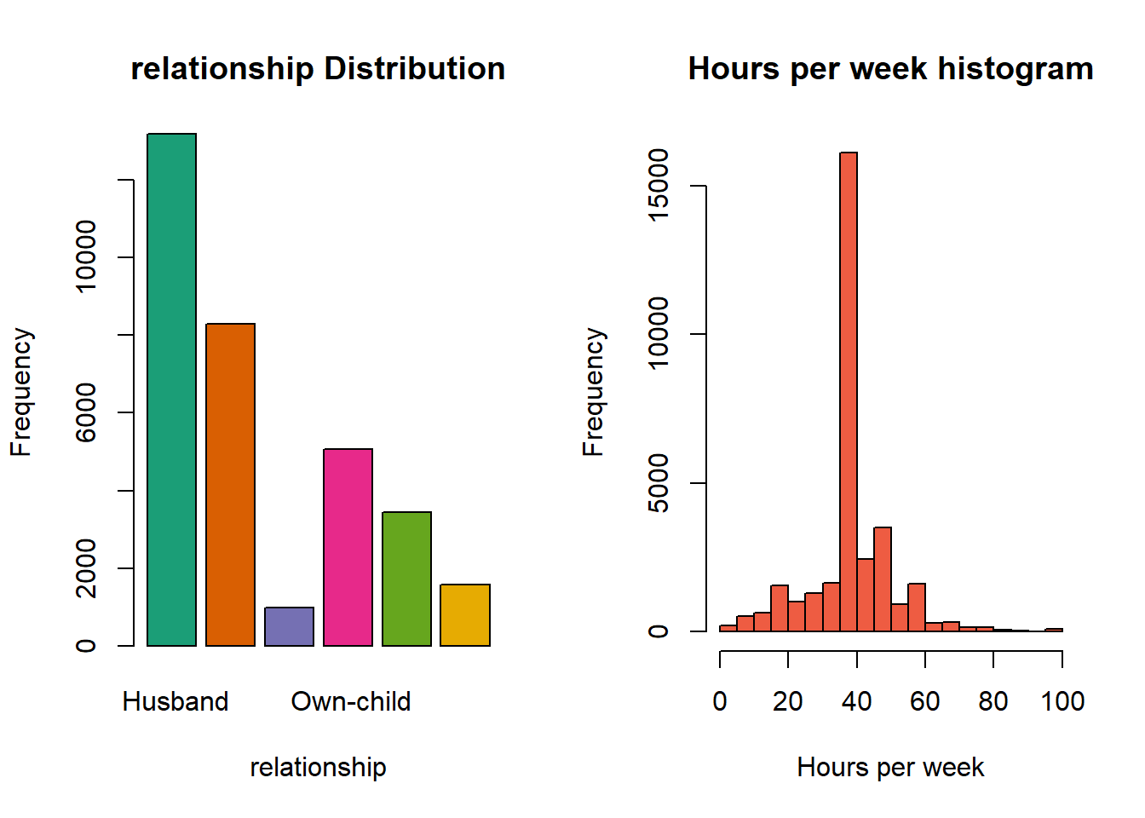
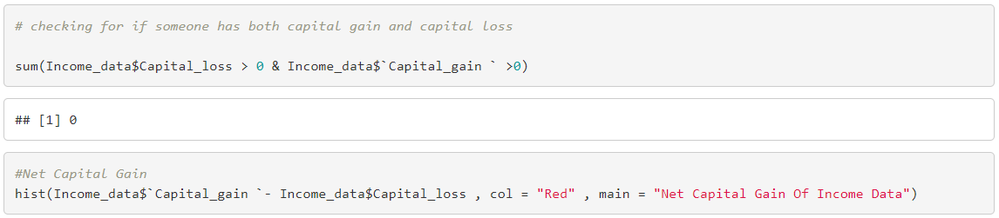
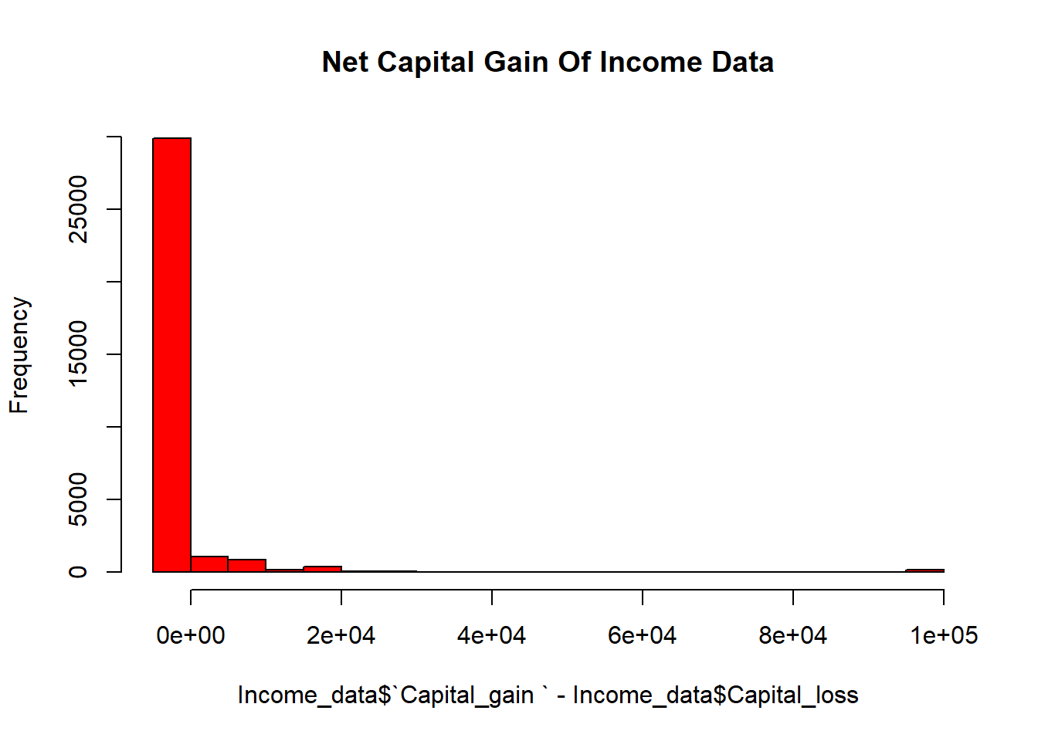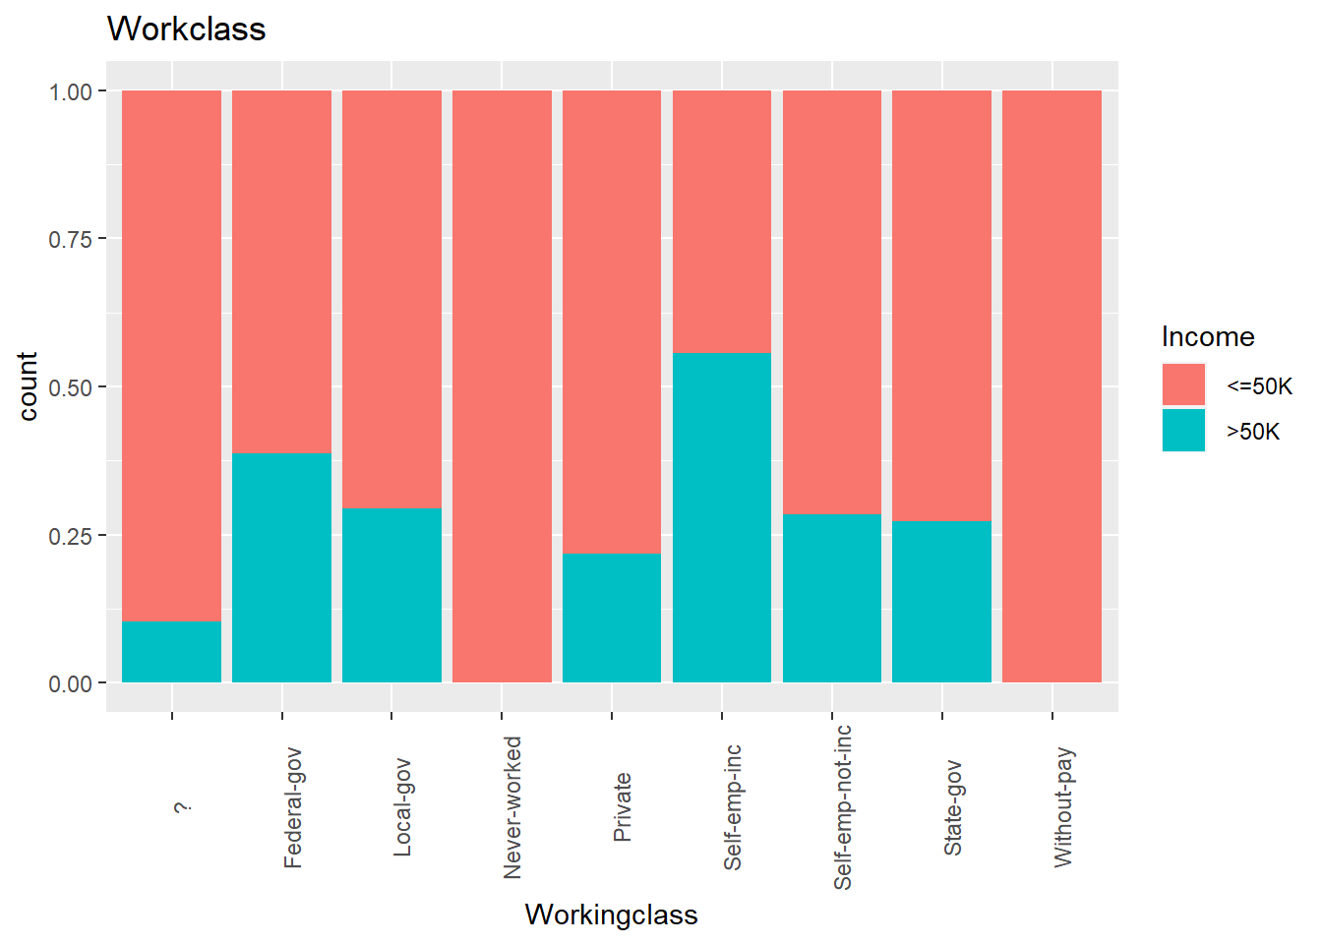
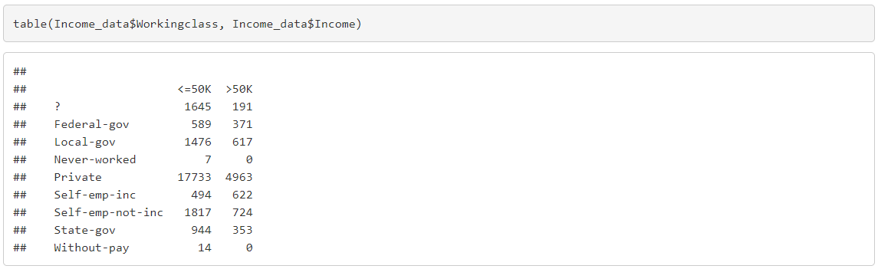
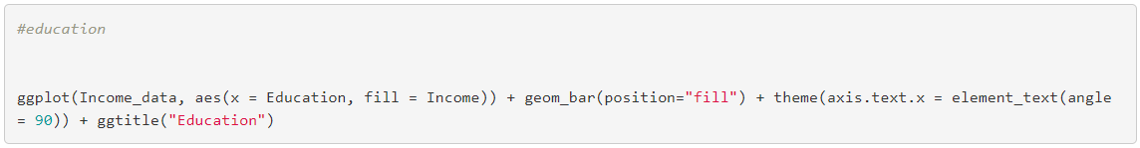
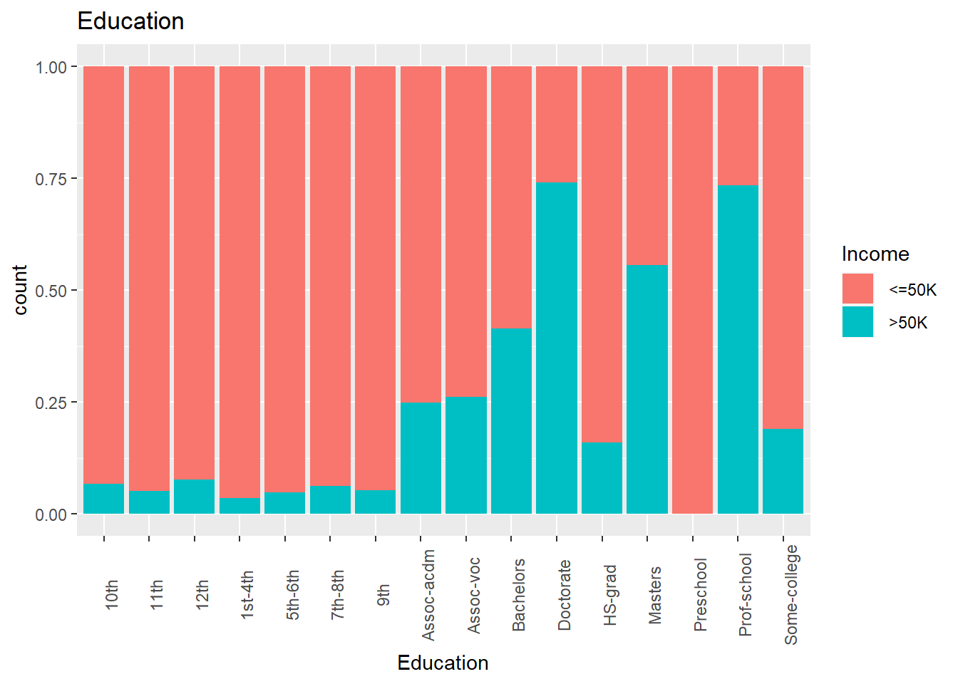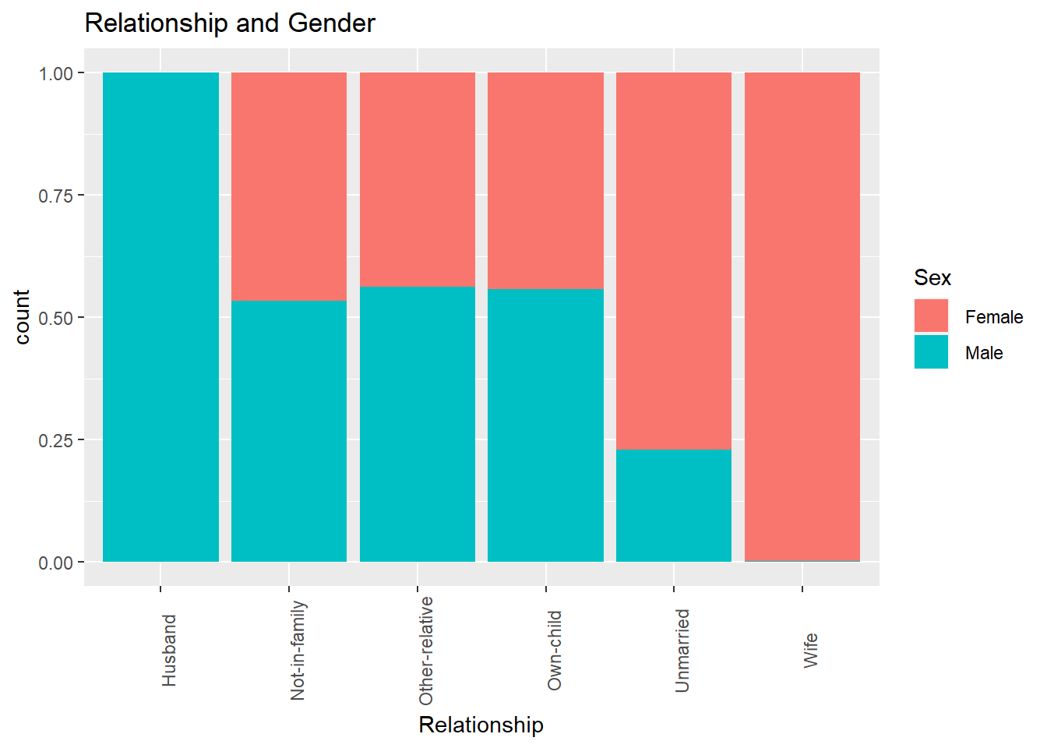
- From the above graph we know what the education plays an important role in income.
- The original levels Husband Not-in-family Other-relative Own-child Unmarried Wife have been replaced by Not-in-family Other-relative Own-child Unmarried Spouse
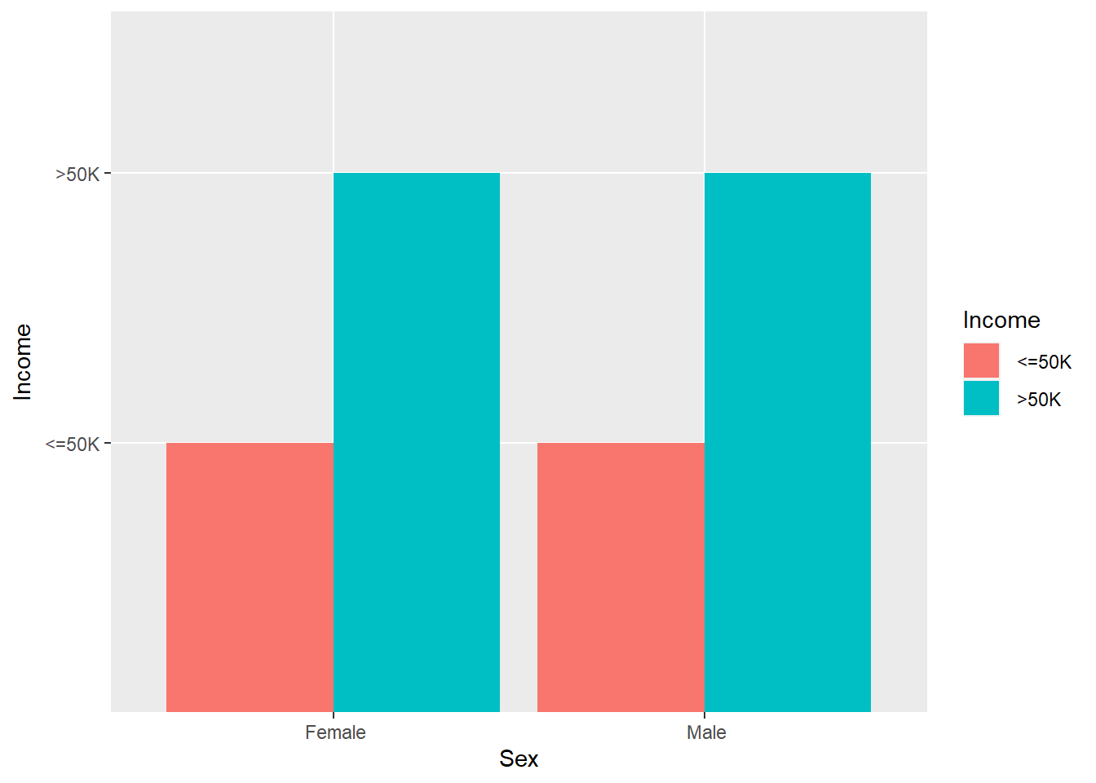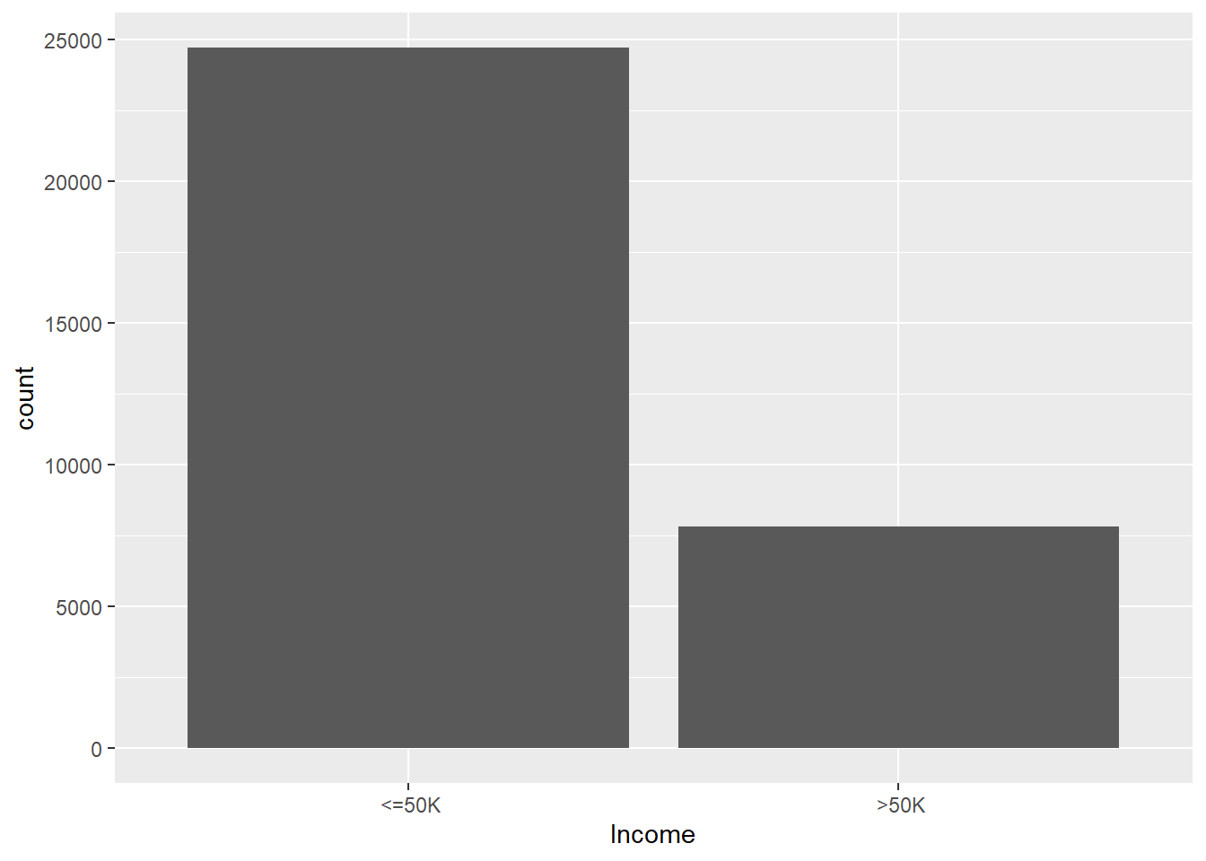
Only about 1/4 of the observations have an Income value of “>$50K” that is 1. To solve this problem, we will under-sample the data, taking 4000 observations for our training set with equal amounts of randomly selected values for Income and 1000 randomly selected observations from the remainder of the data for the test set.

III. Data Preparation and Preprocessing
Removing Variables

We will also remove Native_country because it will most likely not be a very meaningful predictor. Out of the 32560 observations, 90% have the value of “United States”.
After inspecting the predictors Education_num and Education, we see that they are the portraying the same information. Education_num is just the numeric value of Education. We will keep Education because of its interpretability and remove Education_num.

Removing Missing Values
We want to check how many missing values are in the dataset and then remove observations that have them.
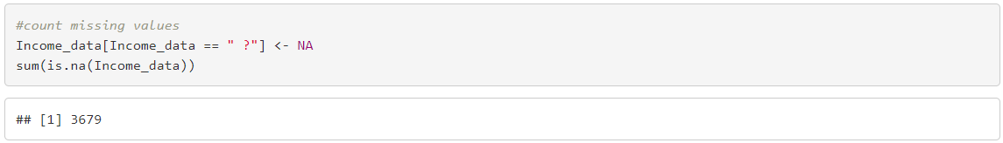
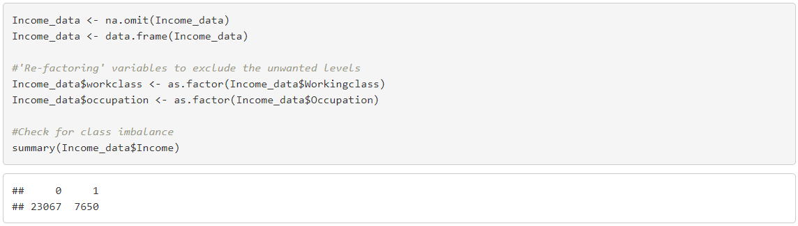
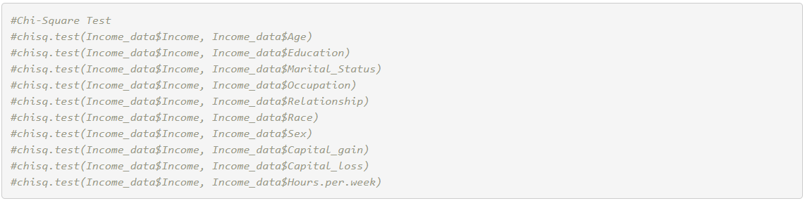
By using chi-squared test we came to know that dependent variables of Income are all the other variables in the dataset except Final_Weight. The Final_Weight which is the final weight determined by the Census Organization is of no use in any of the analysis that we are doing henceforth and is removed. The education_num if a repetitive variable which recodes the categorical variable Education as a numeric variable but will be used in the analysis for decision trees, hence is not being removed.

IV. Data Mining Techniques and Implementation
The datamining flow would be starting from creating training and testing dataset through which it is passed through 3 different methods – Decision Tree, Random Forest, Logistic Regression which is then checked for its Performance i.e. accuracy and AUC of ROC curve (Area Under Curve, Receiver Operation Characteristic)
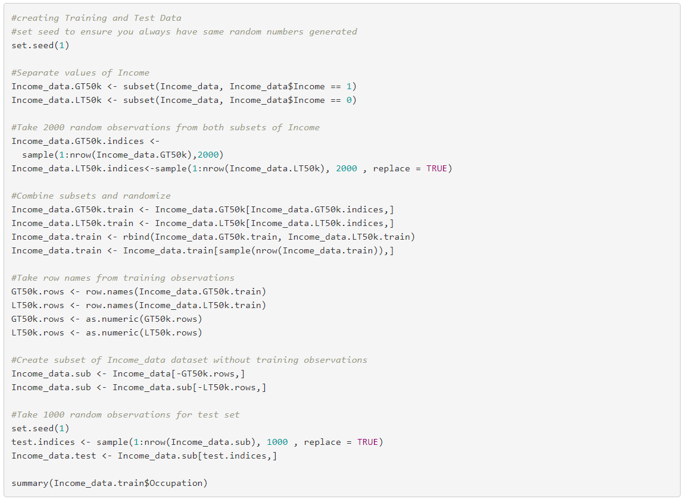
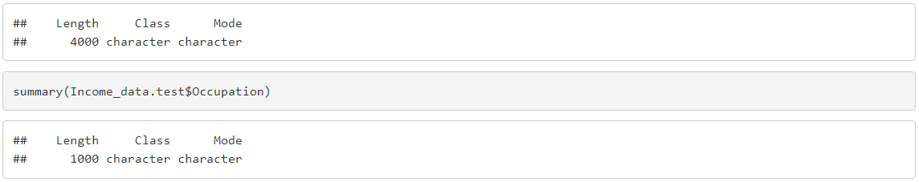
For convenience purposes, we will create Xtrain, Ytrain, Xtest, and Ytest that containing the response and predictor variables for the training and test sets.
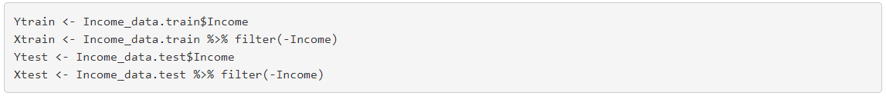
Now that we have concluded the pre-processing step, we can move on to creating models we will use to predict Income.

We will check the model accuracy with the confusion matrix:
Accuracy: Accuracy is one of the most common metrics in measuring the classification models performance. It is defined as the ratio of number of correct predictions over the total predictions made. So, obviously the more the accuracy is the better the model. We should always evaluate our models performance on the test data button the train data since the model is built on the train data it usually performs better on the data it has seen, but test data is something which the model has not seen so we can trust the test data’s metrics. Accuracy = Number of correct predictions / Total number of predictions made

Confusion Matrix: We will use confusion matrix as our second metric as just in case if the accuracies of two models are relatively same, we look at confusion matrix to identify the false negatives and false positives. Here in our case the primary goal is to predict if the person makes above 50k false positives and false negatives helps us in deciding the best model.

##Methods 1. Decision Trees 2. Random Forest 3. Logistic Regression
#Modelling
Decision Tree
A decision tree classifies by choosing a threshold on a feature and splits the data according to a ‘splitting rule’. Since the features need to be numerical, we had to discard certain features and change how we represented others. For example, we could not convert Native_country into numerical values since this would cause an implicit feature ranking skewing our results. However, Education is a feature that can be converted into a numerical value, as a certain level of Education can be higher or lower than others in rank. For this reason, we chose only to consider limited attributes (This is represented as a binary feature with 1 being male and 0 being female). The tree is then built on the training set and used to predict the binary value of the label (whether or not an individual makes more than $50,000) on the test set.

By using the tree() function, we are able to grow a tree on the training set, using Income as the response and all other variables as predictors

(Codes are in appendix)
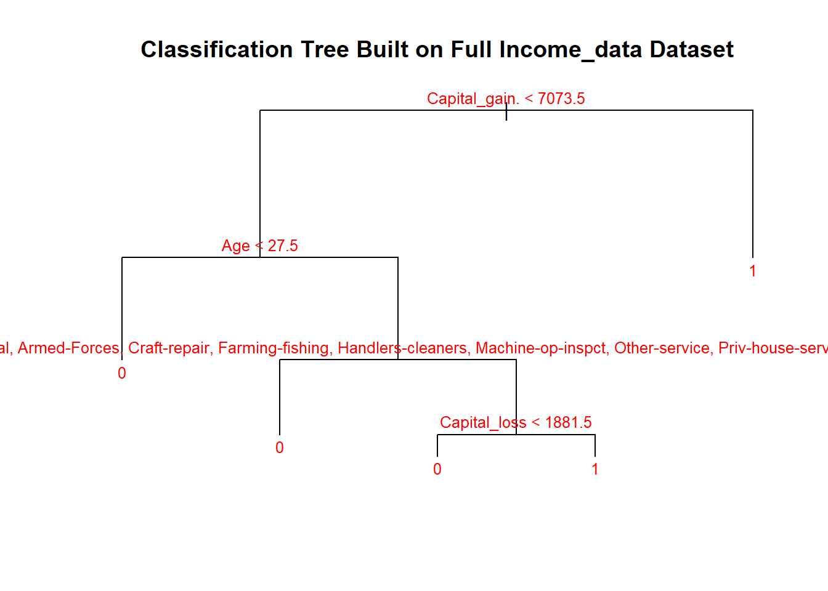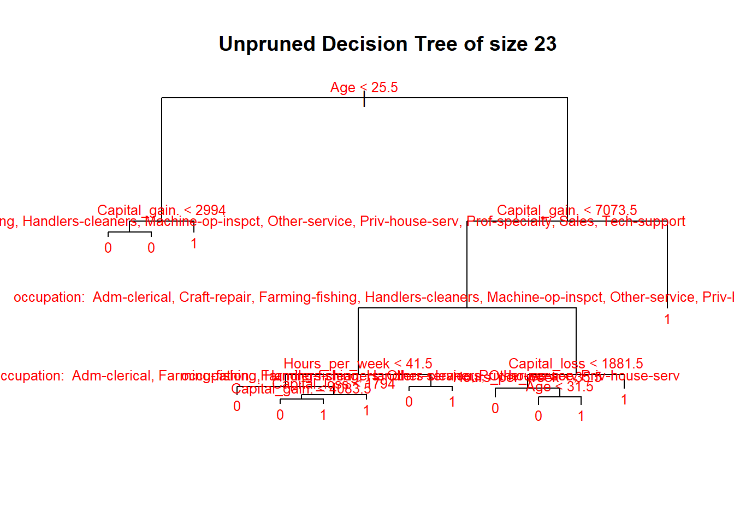
Notice how at the split of each node, there is text describing the predictor variable and certain values within the variable. If an observation has these values, then it moves down the left side of the node. If it does not contain these values, it moves down the right side. The title of this tree is “Unpruned Decision Tree of size 23” because it is has 23 terminal nodes (the 1’s and 0’s at the bottom of the tree) and it is not pruned.
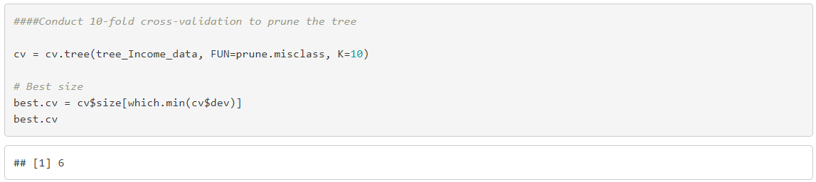
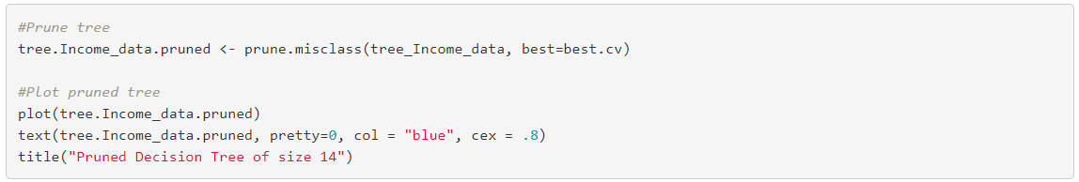
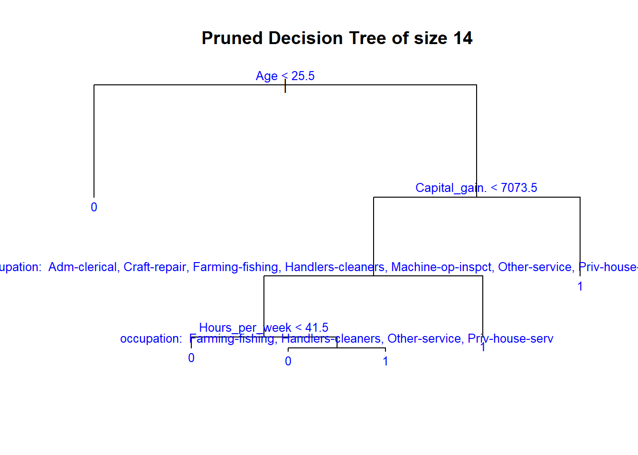
Now that we have our pruned tree, we can do a little bit of analysis on what we can see. One of the advantages of decision trees is that it is easy to visually interpret. Right away, we see that the first node deals with the age predictor and shows that you move down the right side of the tree if you happen to be more than 25.5.
With the pruned tree, we can apply the tree on the training and test sets in order to get our training and test error rates. We will create a function erate() that will calculate the misclassification error rate when given the predicted responses and actual responses as inputs. This function will be used to calculate the error rates for the rest of the models as well.
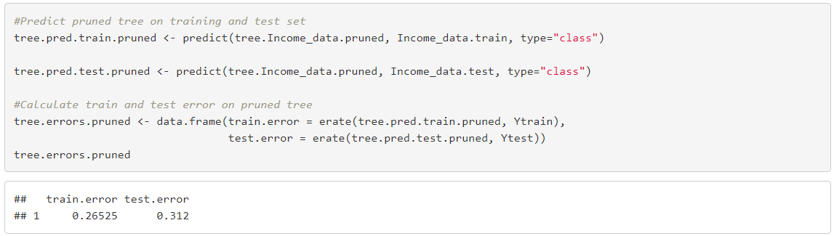
Our pruned tree has a training error of 0.26525 and a test error of 0.312
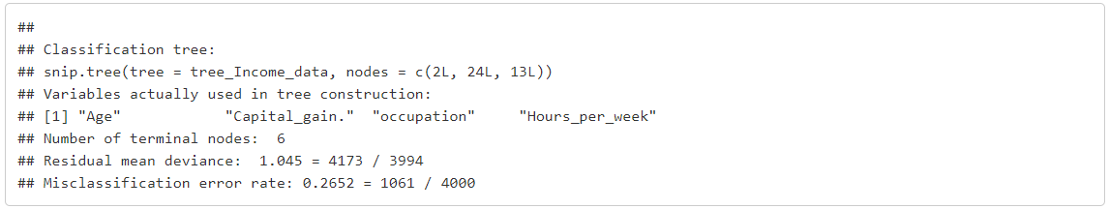
From here, we can see the predictor variables that went into the making of this pruned tree. This means that these were the most important predictors that influence Income.

- Random Forest
Random Forests is a machine learning algorithm that is supervised. It essentially consists of many decision trees that have been bagged prepared. Random forests outperform other models because they can be used for both regression and classification and are relatively simple to understand and incorporate. The random forests model constructs the tree using a random subset of features centered on such, introducing randomness to the model, resulting in a stable, complex, and generalized model Its hyperparameters are almost identical to those of decision trees. The positive thing about random forest models is that they don’t overfit, but the downside is that they can be sluggish and time consuming when the number of trees is high.

To find the optimal number of predictors, we will run a loop comparing different number of selected predictors and determine which gives the lowest misclassification error rate.
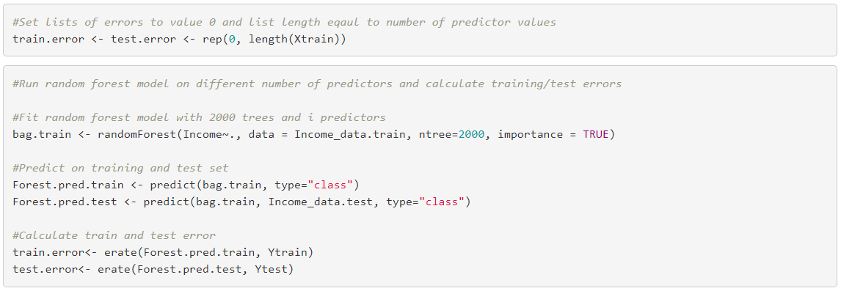
Now we can create a dataframe containing all training and test errors for each set number of predictors used in the model.
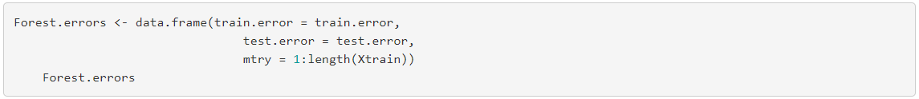
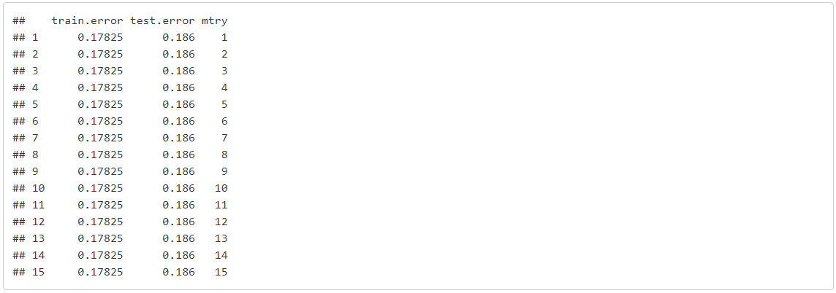
Now we will choose number of predictors that has the lowest test error
After looking at the data frame, we can see that the Random Forest model with the lowest test error used only 4 predictors. This makes sense because it is the default number of predictors used by Random Forests for classification and generally works well.

Now that we have the best number of predictors, we will create the Random Forest model again, but only using 4 predictors and 2000 trees. We will also create a plot that shows the importance of each variable.
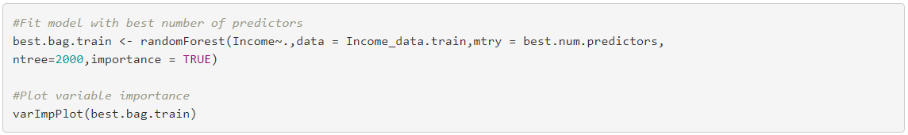
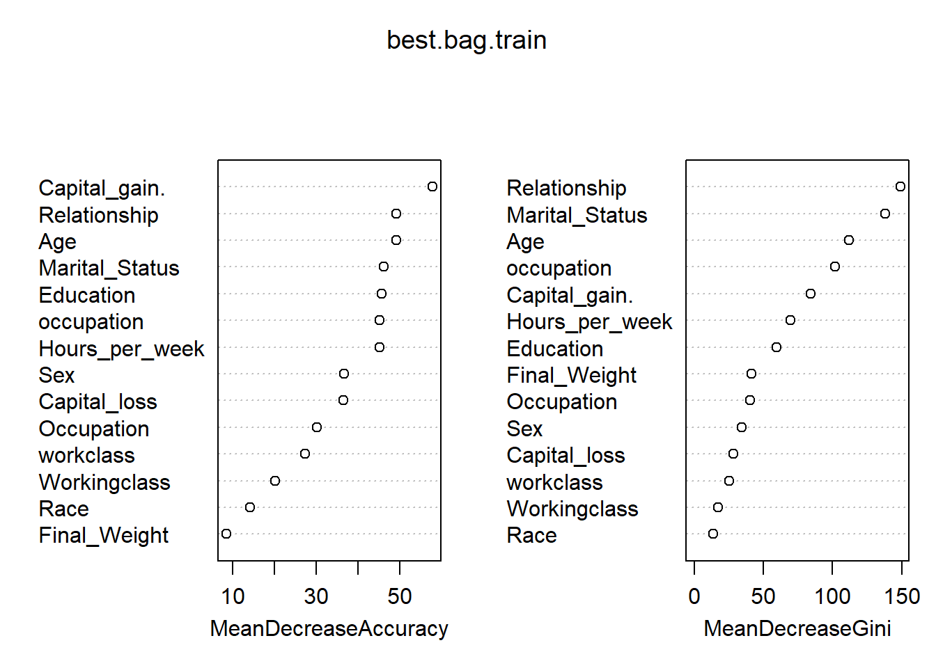
MeanDecreaseAccuracy shows how worse the model does when specific predictors are taken out. The higher the value, the more the accuracy of the model predictions decreases. We will focus on this to rank the importance of our predictor variables. From this graph, we can see that Capital_gain, Education,Age, Occupation, and Hours_per_week made the most difference in determining Income.

MeanDecreaseGini essentially shows the purity of the nodes at the end of the tree. Gini impurity is a measure of how often a randomly chosen element in a set would be incorrectly labeled if labeled. In this case, the higher the MeanDecreaseGini, the less pure the nodes get and more important the predictors are. Some notable variables such as Relationship, Occupation, and Marital_status should also be taken into consideration due to their high MeanDecreaseGini value and prevalence in other models.

Making predictions from the given data
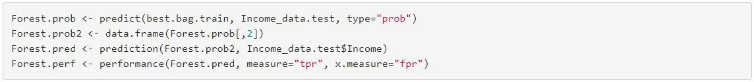
- Logistic Regression
The next model that we apply is Logistic Regression. In datasets where the response variable is binary, Logistic Regression works by modeling the probability that response variable X belongs to a particular category instead of trying to model XX directly.

By using glm (general linear model), we can determine the likelihood of a specific observation having a particular class label. If we assign different thresholds to the probability that a certain class label is created, we can find the different error rates for those thresholds. Performing 10-fold cross-validation will allow us to choose the best threshold that minimizes the misclassification error rate.
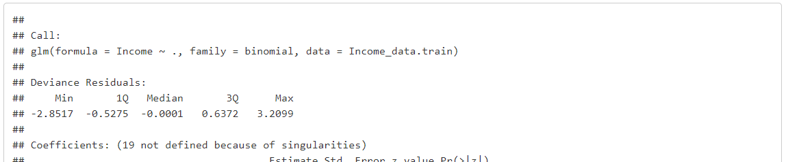

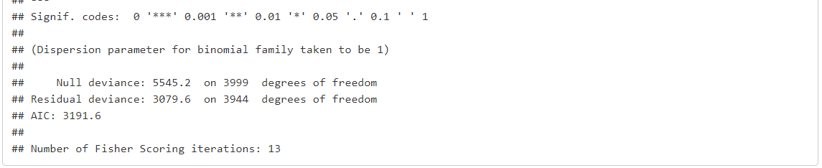
LDA also known as Linear Discriminate Analysis makes predictions by estimating the probability that a new set of inputs belongs to each class. The class that gets the highest probability is the output class and a prediction is made.
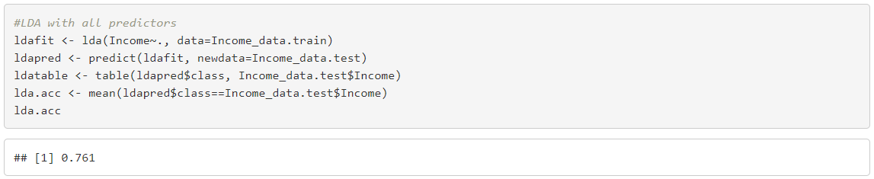
Linear Discriminate Analysis has a higher accuracy than logistic regression in this case. The most likely explanation for this is that, unlike logistic regression, linear discriminate analysis considers naturally distributed predictors. This result illustrates why the predictors are highly likely to be non-normally distributed, as we see in numerical variables like net capital.

V. Performance Evaluation
- Decision Tree
Accuracy through Confusion Matrix
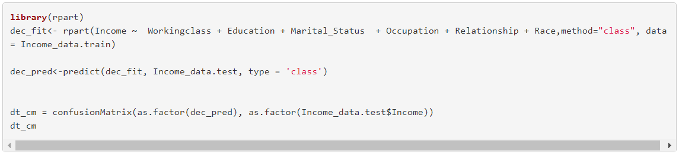
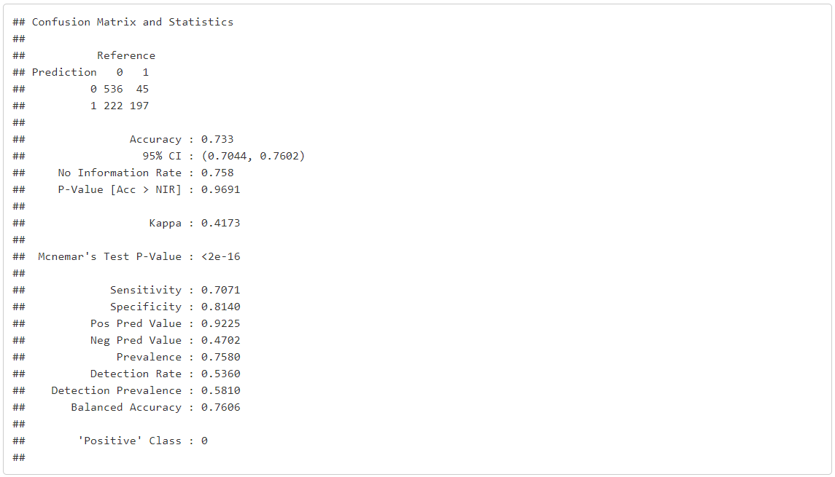
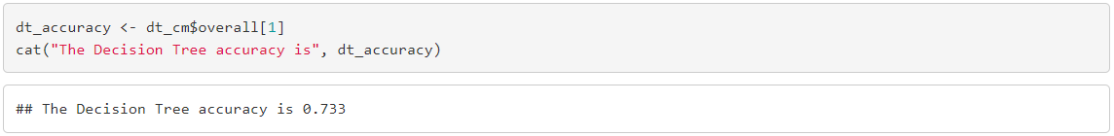
The following are the results of the Decision Tree Analysis. The accuracy using this model is 73.3%. The sensitivity is 70.71% and the specificity is 81.40%. . The kappa rate is just over 40% so the error rate is quite low.

ROC Curve (Code in Appendix) – (AUC = 0.8627769)
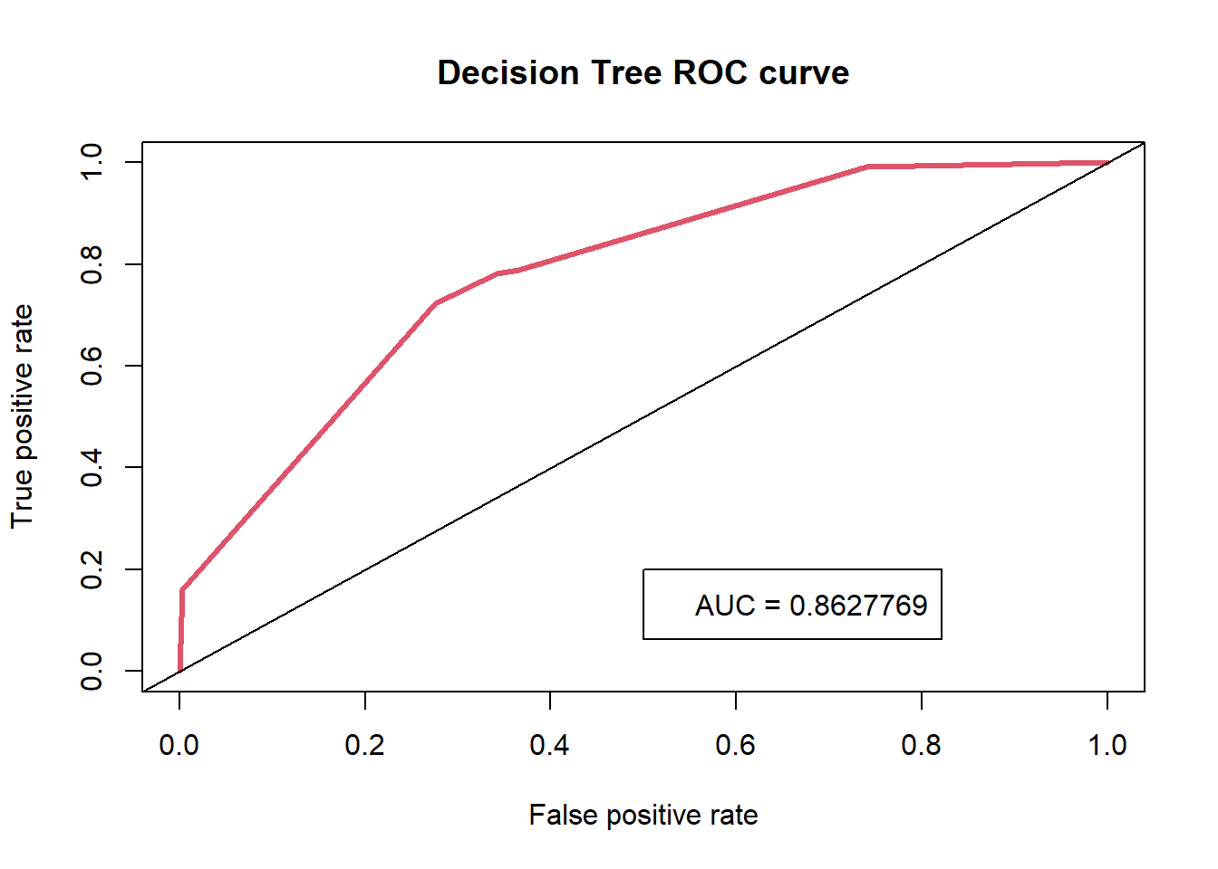
- Random Forest
Accuracy through Confusion Matrix
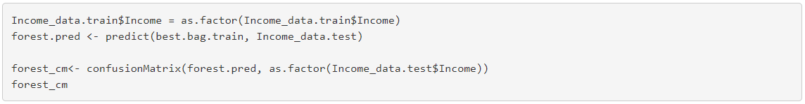
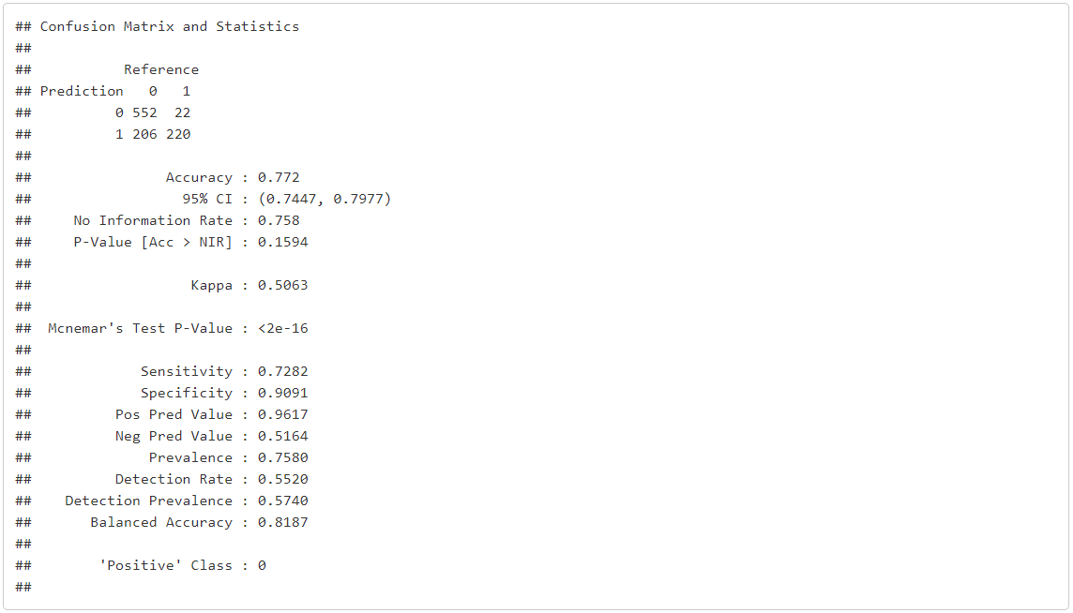
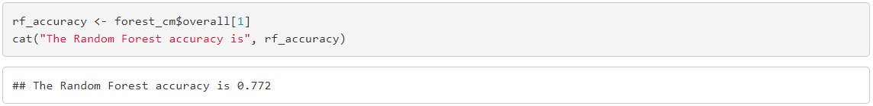
The following are the results of the Random Forest Analysis. The accuracy using this model is 77%. The recall rate is 72.69% which is little high that mean all the positive values are correctly identified, and specificity is 90% which is high that mean above 80% of the negative values in the dataset are correctly identified by the model.

ROC Curve (Code in Appendix) – (AUC = 0.8960673)
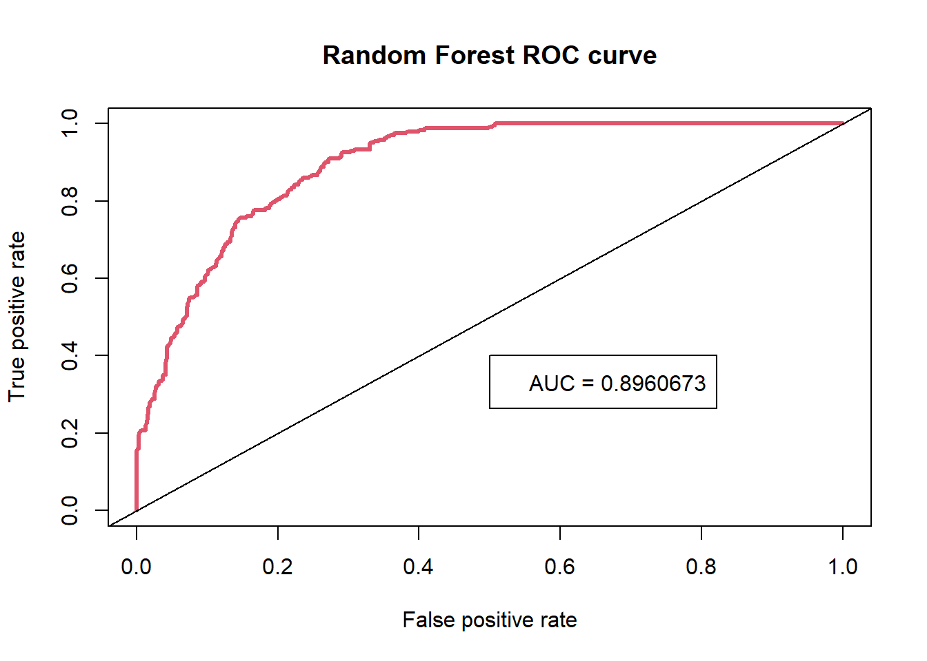

- Logistic Regression
Accuracy through Confusion Matrix
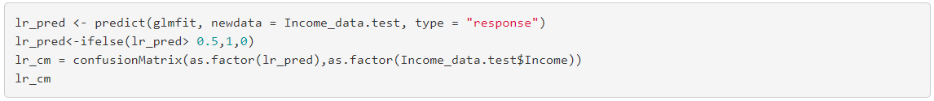
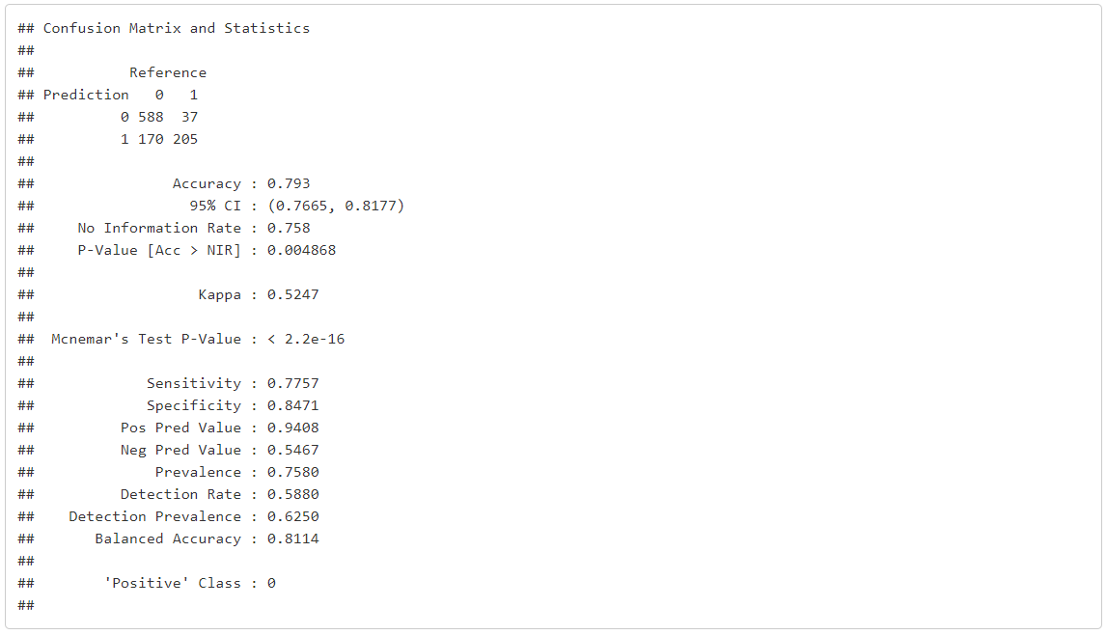
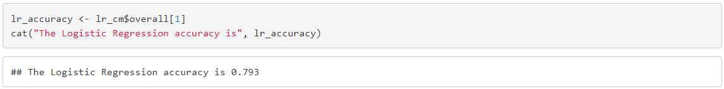

ROC Curve (Code in Appendix) – (AUC = 0.9013934)
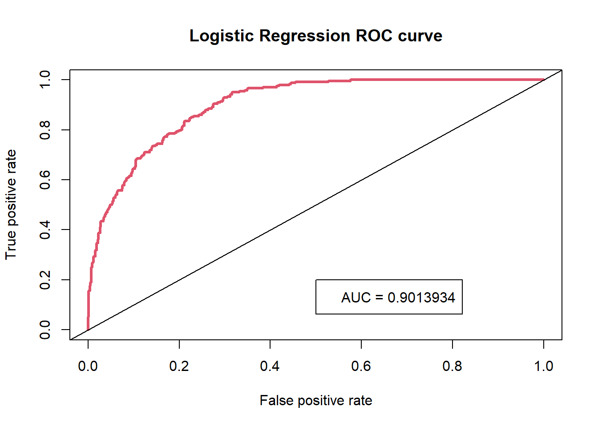

VI. Discussion and Recommendation
At the beginning of this project, the goal was to find a model that accurately predicts if an individual makes more than $50K a year and determine which factors had the largest impact on that response variable (while paying particular attention to Education). With an AUC higher and test misclassification error rate lower than the other two models, Random Forests wins as the best predictive model of the three. When looking at the variables, it was clear that some variables were prominent in having an effect on Income. Education, Relationship, Marital_status, and Occupation were some of those variables. To answer the question that I was most interested in, it was clear that any education level above a High School Diploma had a significant positive affect on determining if an individual made greater than 50K a year.

For further work, I intend on tinkering with the different values associated with Random Forests. I know there is much more to Random Forests than what I have accomplished with it in this project. I would also like to try different pruning methods with Decision Trees and attempt other models as well. Finally, I would like to attempt this whole project again, except with the full dataset. Instead of using 5000, I would want to use all 32560 observations.

VII. Summary
We started by selecting data from UCI Machine Learning Repository which was then explored using primary analysis and visualized. Cleaned the data by removing missing and unwanted values. Then for further modeling data was divided in training and testing data set, which was used for Decision tree, Random forest, Logistic regression. After this performance is individually evaluated using confusion matrix and ROC with the help of AUC. Finally, Logistic Regression was found to be the most suitable method for this model.

Appendix: R Code for use case study

#Load libraries
library(ggplot2)
library(plyr)
library(dplyr)
library(class)
library(tree)
library(randomForest)
library(ROCR)
library(caret)
library(corrplot)
library(RColorBrewer)
library(MASS)
#Reading the data files
Income_data <- read.csv("Income_data.csv")
#Add column labels
Income_data.names <- c("Age",
"Workingclass",
"Final_Weight",
"Education",
"Education_num",
"Marital_Status",
"Occupation",
"Relationship",
"Race",
"Sex",
"Capital_gain ",
"Capital_loss",
"Hours_per_week",
"Native_country",
"Income")
colnames(Income_data) <-Income_data.names

#Show dataset
str(Income_data)
#checking the dimension of the dataset
dim(Income_data)
#summary
summary(Income_data)
#Correlation plot
num.var <- c(1, 3, 5, 11:13)
corrplot(cor(Income_data[,num.var]),type="upper", order="hclust",
col=brewer.pal(n=8, name="RdYlBu"))
par(mfrow=c(1,2))
barplot(table(Income_data$Age), xlab = "Age", ylab = 'Frequency', main = "Age", col= "deepskyblue1")
barplot(table(as.factor(Income_data$Sex)), xlab = 'Sex', ylab = 'Frequency', main = 'Sex', col = c("#F67373", "#73D7F6"))
barplot(table(as.factor(Income_data$Income)), xlab = 'Income level', ylab = 'Frequency', main = 'Target Distribution', col = c("#F67373", "#73D7F6"))
barplot(table(as.factor(Income_data$Marital_Status)), xlab = 'Marital status', ylab = 'Frequency',main = 'Marital Status')
barplot(table(as.factor(Income_data$Race)), xlab = 'Race', ylab = 'Frequency', main = 'Race Distribution', col = brewer.pal(n = 5, name = "PuBu"))
barplot(table(as.factor(Income_data$Education)), xlab = 'Education', ylab = 'Frequency', main = 'Education Distribution', col = brewer.pal(n = 7, name = "Set3"))
hist(Income_data$Capital_gain, xlab = 'Capital gain', ylab = 'Frequency', main = 'Capital Gain histogram', col = 'deepskyblue')
hist(Income_data$Capital_loss, xlab = 'Capital loss', ylab = 'Frequency', main = 'Capital Loss histogram', col = 'deepskyblue3')

barplot(table(as.factor(Income_data$Relationship)), xlab = 'relationship', ylab = 'Frequency', main = 'relationship Distribution', col = brewer.pal(n = 7, name = "Dark2"))
hist(Income_data$Hours_per_week, xlab = 'Hours per week', ylab = 'Frequency', main = 'Hours per week histogram', col = 'tomato2')
# checking for if someone has both capital gain and capital loss
sum(Income_data$Capital_loss > 0 & Income_data$`Capital_gain ` >0)
#Net Capital Gain
hist(Income_data$`Capital_gain `- Income_data$Capital_loss , col = "Red" , main = "Net Capital Gain Of Income Data")
#workclass
ggplot(Income_data, aes(x = Workingclass, fill = Income)) + geom_bar(position="fill") + theme(axis.text.x = element_text(angle = 90)) + ggtitle("Workclass")
table(Income_data$Workingclass, Income_data$Income)
ggplot(Income_data, aes(x = Education, fill = Income)) + geom_bar(position="fill") + theme(axis.text.x = element_text(angle = 90)) + ggtitle("Education")
#relationship vs sex
ggplot(Income_data, aes(x = Relationship, fill = Sex)) + geom_bar(position="fill") + theme(axis.text.x = element_text(angle = 90)) + ggtitle("Relationship and Gender")
ggplot(Income_data, aes(x=Sex , y=Income)) +
geom_bar(aes(fill = Income), stat="Identity", position="dodge")
ggplot(Income_data, aes(x=Income)) +
geom_bar(stat="count")
#Recode variables
Income_data$Income <- ifelse(Income_data$Income == " <=50K", 0, 1)
Income_data$Income <- as.factor(Income_data$Income)

# Removing variables
ggplot(Income_data , aes(x = Native_country)) +geom_bar()
Income_data <- subset(Income_data , select = -c(Education_num , Native_country))
#count missing values
Income_data[Income_data == " ?"] <- NA
sum(is.na(Income_data))
Income_data <- na.omit(Income_data)
Income_data <- data.frame(Income_data)
#'Re-factoring' variables to exclude the unwanted levels
Income_data$workclass <- as.factor(Income_data$Workingclass)
Income_data$occupation <- as.factor(Income_data$Occupation)
#Check for class imbalance
summary(Income_data$Income)
#Chi-Square Test
chisq.test(Income_data$Income, Income_data$Age)
chisq.test(Income_data$Income, Income_data$Education)
chisq.test(Income_data$Income, Income_data$Marital_Status)
chisq.test(Income_data$Income, Income_data$Occupation)
chisq.test(Income_data$Income, Income_data$Relationship)
chisq.test(Income_data$Income, Income_data$Race)
chisq.test(Income_data$Income, Income_data$Sex)
chisq.test(Income_data$Income, Income_data$Capital_gain)
chisq.test(Income_data$Income, Income_data$Capital_loss)
#chisq.test(Income_data$Income, Income_data$Hours.per.week)
#creating Training and Test Data
#set seed to ensure you always have same random numbers generated
set.seed(1)

#Separate values of Income
Income_data.GT50k <- subset(Income_data, Income_data$Income == 1)
Income_data.LT50k <- subset(Income_data, Income_data$Income == 0)
#Take 2000 random observations from both subsets of Income
Income_data.GT50k.indices <-sample(1:nrow(Income_data.GT50k),2000,replace = TRUE)
Income_data.LT50k.indices<-sample(1:nrow(Income_data.LT50k), 2000 , replace = TRUE)
#Combine subsets and randomize
Income_data.GT50k.train <- Income_data.GT50k[Income_data.GT50k.indices,]
Income_data.LT50k.train <- Income_data.LT50k[Income_data.LT50k.indices,]
Income_data.train <- rbind(Income_data.GT50k.train, Income_data.LT50k.train)
Income_data.train <- Income_data.train[sample(nrow(Income_data.train)),]
#Take row names from training observations
GT50k.rows <- row.names(Income_data.GT50k.train)
LT50k.rows <- row.names(Income_data.LT50k.train)
GT50k.rows <- as.numeric(GT50k.rows)
LT50k.rows <- as.numeric(LT50k.rows)
#Create subset of Income_data dataset without training observations
Income_data.sub <- Income_data[-GT50k.rows,]
Income_data.sub <- Income_data.sub[-LT50k.rows,]
#Take 1000 random observations for test set
set.seed(1)
test.indices <- sample(1:nrow(Income_data.sub), 1000 , replace = TRUE)
Income_data.test <- Income_data.sub[test.indices,]

summary(Income_data.train$Occupation)
summary(Income_data.test$Occupation)
Ytrain <- Income_data.train$Income
Xtrain <- Income_data.train %>% filter(-Income)
Ytest <- Income_data.test$Income
Xtest <- Income_data.test %>% filter(-Income)
set.seed(123)
erate <- function(predicted.value, true.value){ return(mean(true.value!=predicted.value))
}#Fit tree on entire dataset
tree.full <- tree(Income ~ ., data= Income_data)
#Plot tree
plot(tree.full)
text(tree.full, pretty = 0, cex = .8, col = "red")
title("Classification Tree Built on Full Income_data Dataset")
#Fitting the model on training set
tree_Income_data <- tree(Income ~ . , data = Income_data.train)
tree_Income_data <- tree(Income ~ . ,
data = Income_data.train,
control = tree.control(4000,
mincut = 5,
mindev = 0.003))
#plotting the tree
plot(tree_Income_data)
text(tree_Income_data, pretty = 0, cex = .8, col = "red")
title("Unpruned Decision Tree of size 23")
#Predict on training and test set
tree.pred.train <- predict(tree_Income_data, Income_data.train, type="class")
tree.pred.test <- predict(tree_Income_data, Income_data.test, type="class")
#Calculate train and test error on tree
tree.errors <- data.frame(train.error = erate(tree.pred.train, Ytrain),
test.error = erate(tree.pred.test, Ytest))
tree.errors
####Conduct 10-fold cross-validation to prune the tree
cv = cv.tree(tree_Income_data, FUN=prune.misclass, K=10)
# Best size
best.cv = cv$size[which.min(cv$dev)]
best.cv
#Prune tree
tree.Income_data.pruned <- prune.misclass(tree_Income_data, best=best.cv)
#Plot pruned tree
plot(tree.Income_data.pruned)
text(tree.Income_data.pruned, pretty=0, col = "blue", cex = .8)
title("Pruned Decision Tree of size 14")
#Predict pruned tree on training and test set
tree.pred.train.pruned <- predict(tree.Income_data.pruned, Income_data.train, type="class")
tree.pred.test.pruned <- predict(tree.Income_data.pruned, Income_data.test, type="class")

#Calculate train and test error on pruned tree
tree.errors.pruned <- data.frame(train.error = erate(tree.pred.train.pruned, Ytrain),
test.error = erate(tree.pred.test.pruned, Ytest))
tree.errors.pruned
summary(tree.Income_data.pruned)
library(rpart)
dec_fit<- rpart(Income ~ Workingclass + Education + Marital_Status + Occupation + Relationship + Race,method="class", data = Income_data.train)
dec_pred<-predict(dec_fit, Income_data.test, type = 'class')
dt_cm = confusionMatrix(as.factor(dec_pred), as.factor(Income_data.test$Income))
dt_cm
dt_accuracy <- dt_cm$overall[1]
cat("The Decision Tree accuracy is", dt_accuracy)
## Decision tree ROC
tree_p1 <- predict(tree.Income_data.pruned , Income_data.test)
tree_p2 <- data.frame(tree_p1[,2])
tree_predict <- prediction(tree_p2 , Income_data.test$Income)
tree_predf <- performance(tree_predict, measure = "tpr" , x.measure = "fpr")
.#AUC
auc = performance(tree_predict, "auc")@y.values
auc
plot(tree_predf, col=2, lwd=3, main="Decision Tree ROC curve")
legend(.5,.2, "AUC = 0.8627769")
abline(0,1)
#Set lists of errors to value 0 and list length eqaul to number of predictor values
train.error <- test.error <- rep(0, length(Xtrain))
#Fit random forest model with 2000 trees and i predictors
bag.train <- randomForest(Income~., data = Income_data.train, ntree=2000, importance = TRUE)

#Predict on training and test set
Forest.pred.train <- predict(bag.train, type="class")
Forest.pred.test <- predict(bag.train, Income_data.test, type="class")
#Calculate train and test error
train.error<- erate(Forest.pred.train, Ytrain)
test.error<- erate(Forest.pred.test, Ytest)
Forest.errors <- data.frame(train.error = train.error,
test.error = test.error,
mtry = 1:length(Xtrain))
Forest.errors
best.num.predictors <- Forest.errors$mtry[which.min(Forest.errors$test.error)]
#Show training error, test error, and number of predictors
Forest.errors[best.num.predictors,]
#Fit model with best number of predictors
best.bag.train <- randomForest(Income~.,data = Income_data.train,mtry = best.num.predictors,
ntree=2000,importance = TRUE)
#Plot variable importance
varImpPlot(best.bag.train)
Forest.prob <- predict(best.bag.train, Income_data.test, type="prob")
Forest.prob2 <- data.frame(Forest.prob[,2])
Forest.pred <- prediction(Forest.prob2, Income_data.test$Income)
Forest.perf <- performance(Forest.pred, measure="tpr", x.measure="fpr")
Income_data.train$Income = as.factor(Income_data.train$Income)
forest.pred <- predict(best.bag.train, Income_data.test)
forest_cm<- confusionMatrix(forest.pred, as.factor(Income_data.test$Income))
forest_cm
rf_accuracy <- forest_cm$overall[1]
#AUC
auc = performance(Forest.pred, "auc")@y.values
auc
#Plot ROC with AUC
plot(Forest.perf, col=2, lwd=3, main="Random Forest ROC curve")
legend(.5,.4, "AUC = 0.8960673")
abline(0,1)
glmfit <- glm(Income~., data=Income_data.train, family=binomial)
summary(glmfit)
#LDA with all predictors
ldafit <- lda(Income~., data=Income_data.train)
ldapred <- predict(ldafit, newdata=Income_data.test)
ldatable <- table(ldapred$class, Income_data.test$Income)
lda.acc <- mean(ldapred$class==Income_data.test$Income)
lda.acc
lr_pred <- predict(glmfit, newdata = Income_data.test, type = "response")
lr_pred<-ifelse(lr_pred> 0.5,1,0)
lr_cm = confusionMatrix(as.factor(lr_pred),as.factor(Income_data.test$Income))
lr_cm
lr_accuracy <- lr_cm$overall[1]
cat("The Logistic Regression accuracy is", lr_accuracy)
lr_p1 <- predict(glmfit , Income_data.test)
#lr_p2 <- data.frame(lr_p1[,2])
lr_predict <- prediction(lr_p1 , Income_data.test$Income)
lr_predf <- performance(lr_predict, measure = "tpr" , x.measure = "fpr")
#AUC
auc = performance(lr_predict, "auc")@y.values
plot(lr_predf, col=2, lwd=3, main="Logistic Regression ROC curve")
legend(.5,.2, "AUC = 0.9013934")
abline(0,1)

